**FUZZY LOGIC BASED CROP DIVERSIFICATION TO INCREASE CROP YIELD**

**S DIVYA MEENA, POKALA RAMA MEGHANA, CHENNAREDDY SAI SINDHU, KOPPARLA VARSHINI, CHITTEMREDDY GNANENDAR REDDY, J SHEELA**

1,*Assistant Professor Sr. Grade 1, SCOPE, VIT-AP University, India

2School of Computer Science and Engineering, VIT-AP University, Amaravathi, India

**\***[**sheela.j@vitap.ac.in**](mailto:sheela.j@vitap.ac.in)

# **ABSTRACT**

Nowadays, farmers are facing a major loss in crop production due to various reasons such as reduction in soil fertility, lack of irrigation facilities, lack of adequate knowledge on the suitable crop for the persisting soil. In this paper we attempt to predict the suitable crops for the given area of land using various parameters such as nutrient content in soil, meteorological parameters and geographical conditions and of the land by using fuzzy logic-based crop diversification system to suggest rural farmers from which farmer can cultivate multiple crops in the same area which can profit them economically. The proposed model has been planned to deal with the ten main crops grown in Andhra Pradesh such as Chili, Cotton, Groundnut, Paddy, Sugarcane, Tobacco, Mango, Millets,Pulses, Wheat. different fuzzy rule bases were created for every crop to achieve rapid parallel processing.

# **KEYWORDS:** Fuzzy logic- Soil evaluation- Soil Classification-Soil suitability - Crop diversification

# **INTRODUCTION**

Agriculture is a key profession in India. It is the wide-ranging economic sector and takes part in a very major role in the total growth of the country. Over a major percentage of the country is used for farming to meet the requirement of 1.4 billion people. Therefore, the introduction of new agricultural technology is most important.This will benefit the farmers in our state. Previous crop and yield predictions were based on the farmer's experience at a specific location. They would rather have early or neighborhood or more trending crops in the nearby area just for their land and do not have sufficient knowledge of the soil nutrient content of the land such as nitrogen, phosphorus and potassium.The current situation of lack of crop rotation and inadequate nutrient supply leads to reduced yields and soil contamination, damaging the top layers. Take all these issues into consideration. For the country, one of the most important aspects of its growth revolves around the possibility of producing food. Production of important food crops for generations. It is related to agriculture. But in reality, rapid population growth is the greatest concern of our society. Range of Agriculture has been severely compromised, especially in terms of land use and fertility. Farmers' education and technical awareness are unaware of innovative cultivation systems, tools and techniques.They don’t have knowledge of GM seeds that significantly improve post-harvest yields. There is a unavoidable urge to improve the technical skills of farmers so that they are familiar with the happening technological developments around the globe. Successful agricultural results mainly depend on selecting the right crops for the suitable lands.This project uses a fuzzy logic-based crop diversification system to propose crops that can be cultivated on land based on attributes such as soil nutrient content, irrigation scheme, temperature, and rainfall.Our aim is to reduce such failures by suggesting the suitable crops according to the conditions prevailing in that area and thriving towards economic growth of the farmers in rural areas of Andhra Pradesh. Following are the major part of the work;

* The purpose of our project is to suggest the suitable crop for a specific land, using the attributes like the nutrients present in the soil, temperature, humidity and irrigation facilities.
* This could reduce the loss for farmers by increasing the yield of the crop.

# **LITERATURE SURVEY**

Collecting large datasets to predict the evolution of features of interest in outdoor environments has not yet been fully utilized. First, experts assume that environmental features are equally important during the learning process and process local information completely to improve predictive accuracy performance. The most difficult problem is to understand the structure of a class as a dynamically evolving entity that can be affected by the environment. This is one of the reasons why most decision models do not work well when it comes to data mining.

1. **Crop diversification using CNN:**

Several deep CNN models have been presented in recent years to handle various computer vision difficulties. Most deep CNNs have a straightforward design, with convolution layers and pooling layers chained together before one or more fully linked layers. LeNet [6], AlexNet [7], ZFNet [8], and VGGnet [9] are some of these models. Other CNN designs, such as GoogleLeNet [10], ResNet [11], DenseNet [12], Inception V3 [13], Inception V4 [14], and InceptionResNet [15], deliver more detailed, complicated, and reliable findings. To do. These CNN architectures are the most often used in the literature. However, new efficient and lightweight structures have just lately been presented.. These models feature a limited number of trainable parameters and are well-suited to compact, low-computational devices, resulting in quicker processing rates. MobileNet and ShuffleNet, to name a few, are lightweight variants. Many research have demonstrated that 2DCNN-based models may produce remarkable results in plant/crop classification with great spatial and spectral resolution. Object detection methods like YOLOv3 and FasterRCNN are used to build some of these models. Others use segmentation algorithms as Mask RCNN, SegNet, and UNet. The fundamental distinction between the object detection-based and segmentation-based approaches is that the first merely predicts the bounding boxes around each plant of interest in the input picture. The segmentation-based technique, on the other hand, accurately forecasts the mask for each crop or plant. For multi-temporal plant categorization from satellite photos, several alternative architectures are becoming more popular. To capture temporal information, researchers employed one-dimensional CNN (Conv1D) and recurrent neural networks (RNN, including long short-term memory (LSTM)). However, there have been few research on multi-period plant categorization using UAV photos. This research did not look at multi-temporal plant taxonomy. As a result, we employed RGB and spectral UAV photos in this work to analyze solely plant taxonomy from a spatial and spectral perspective using a 2D CNN-based technique.

1. **Crop diversification using digital image processing:**

Image Preprocessing: The main role of the preprocessing step is to perform different types of tasks on the input image. Basically, it emphasizes the image by preparing it suitable for segmentation. When the preprocessing of the input image is complete, a sub-image of the individual numbers is formed from the sequence of images. The preprocessed number image is segmented into sub-images of individual numbers, and each number is assigned a number. Individual digits are scaled in pixels. This step uses edge detection techniques to segment the dataset image. Feature extraction: When the pre-processing and segmentation stages are complete, the pre-processed image is displayed in the form of a matrix containing the component of a very large image. Classification & Recognition: In the Classification & Recognition step, the draw out feature vectors are taken as separate inputs for every classifier given in the following. To present a working system model, the draw out features are merged and described using three classifiers like Support Vector Machine, Random Forest Classifier, K-Nearest Neighbor.

1. **Crop diversification using fuzzy logic:**

Over the last three decades, various expert systems have been introduced as useful tools in different areas of agriculture.Interval fuzzy logic-based approach is used to evaluate fuzzy agricultural modeling 207 sensor data and whether weather conditions are suitable for the growth of pests, especially fungi, depending on parameters such as leaf wetness, temperature and humidity. He put forward an expert system to help farmers make suitable decisions to improve crop production at lower cost, regardless of adverse soil conditions on cultivated land [17]. Domain experts generally rely on their conscious mind when solving problems. We also use suspicious and ambiguous terms. For example, farmers say, "Whatever the quality of the soil is good, rainfall determines the results of crops. Other experts have the basis for hearing the problems presented in this way. So, it's okay to understand and decipher this announcement, but computer engineers and programmers will have a hard time providing the computer with a similar level of understanding. The question is, how can we expose the knowledge of agriculture experts that utilizes indistinct and equivocal terms in a system. We can answer section fuzzy logic.In contrast to standard binary logic, fuzzy logic is a collection of mathematical rules aimed at conveying information depending on the degree of membership. It proves to be an effective technique for coping with ambiguity and uncertainty. Itwas created in order to increase tractability, resilience, and low-cost solutions to real-world situations. In many real-life situations where uncertainty is a factor, fuzzy logic has been used. Agricultural diagnostic [18] is a good example of ambiguity, uncertainty, and ambiguity. In agriculture, fuzzy logic can help make conclusions that are erroneous, ambiguous, and incomplete. We built a multi-class classification algorithm that aids farmers in making crop-growing selections on individual farmlands by combining the fuzzy and softest techniques. Calculating variable weights, transforming continuous data to fuzzy values, and creating classification rules are the three key aspects of the model. Use a crude technique based on dominance to calculate the relative weights of the variables. To transform continuous data into fuzzified values, a fuzzy proximity relationship is used. The bijective soft set technique is used to develop classification rules for fourteen different agricultural crops, including rice, groundnut, sugarcane, wheat, maize, millets, chilies, pulses, cotton, and tobacco. The generated model was evaluated with an agriculture dataset, and the validation dataset revealed 92 percent accuracy, indicating that the model is confident and resilient for agriculture development. The suggested model is also compared to three common classifiers: naive Bayes, support vector machine, and J48. The acquired experimental findings revealed that the suggested model has a good predictive performance when compared to other classifiers.

# **PROPOSED METHODOLOGY**

We used fuzzy logic to develop the model since there are few flaws in CNN and image processing models of crop diversification. Based on soil contents and environmental characteristics such as soil nutrients, temperature, humidity, rainfall, soil type, and season, the proposed method will advise the best suited crop for a given plot of land.

1. **Data Collection**

Data collection is the most efficient approach for gathering and measuring data from many sources such as government websites, the APMC website, and so on. To create a rough dataset for the system. The following characteristics must be included in this dataset: Season ii) Temperature iii) Humidity iv) Rainfall v) Crop data vi) NPK levels vii) Soil type is some of the characteristics that will be taken into account for crop forecast. We collect prior year rainfall data for the yearly rainfall projection. After gathering data from a variety of sources. Before training the model, the data must be preprocessed. Starting with reading the obtained dataset and ending with data cleaning, data preparation may be done in several steps. Data cleaning removes certain redundant properties from datasets, which are not used in crop prediction. As a result, we must remove unnecessary characteristics and datasets with missing values. To improve accuracy, we must remove these missing values or fill them with undesirable nan values. Then decide on a model's objective. Using the sklearn package, the dataset will be divided into training and test sets once it has been cleaned.

1. **Choosing Input Parameters**

The final set of input qualities has been chosen after extensive research. After reviewing a lot of material on various crops in Andhra Pradesh, we discovered certain extremely common factors that might entirely determine the crop to be cultivated. The authors used the analogy that, much as a certain hash requires a specific collection of values, there is a mapping between a crop and a specific set of favorable environmental conditions. Our input parameters are these f natural factors. Only natural characteristics that favor a crop have been included in this study since, after all, crop selection should result in the maximum yield among all other options. The starting point for input parameters

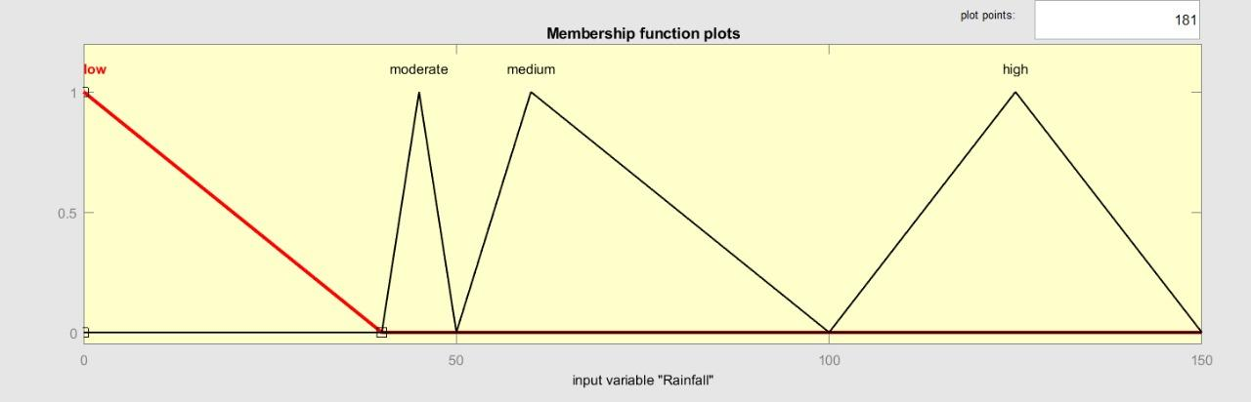

**Fig 1: Rainfall range is defined Low[0cm,40cm], Moderate[40cm,50cm], Medium[50cm,100cm], High[100cm,150cm]**

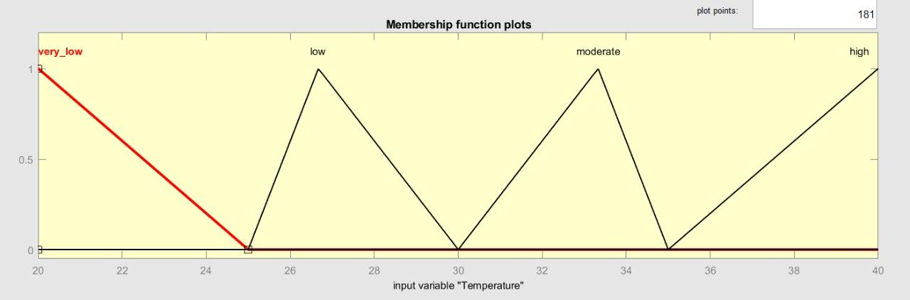

**Fig 2: Temperature range is defined Very_Low[20,25], Low[25,30], Moderate[30,35], High[35,40]**

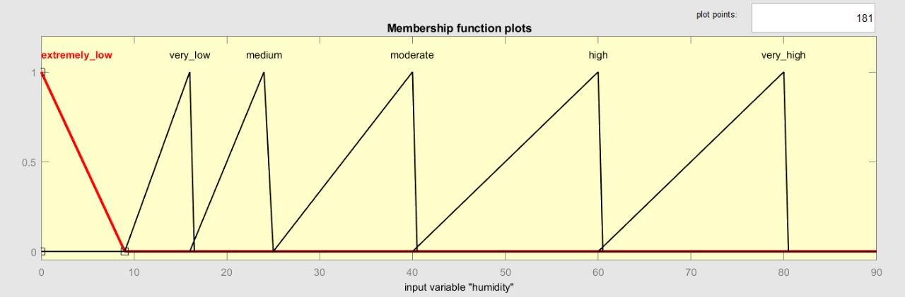

**Fig3: Humidity range is defined as Extremely_low[0,9], Very_low[9,16], Medium[16,25], Moderate[25,40], High[40,60], and Very_High[60,80]**

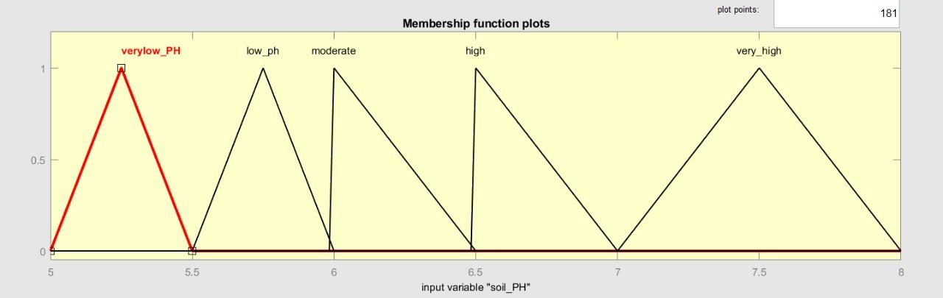

**Fig 4: Membership function for Soil_PH is defined as VeryLow_PH[5,5.5], Low_PH[5.5,6], Moderate[6,6.5], High[6.5,7], Very_high[7,8]**

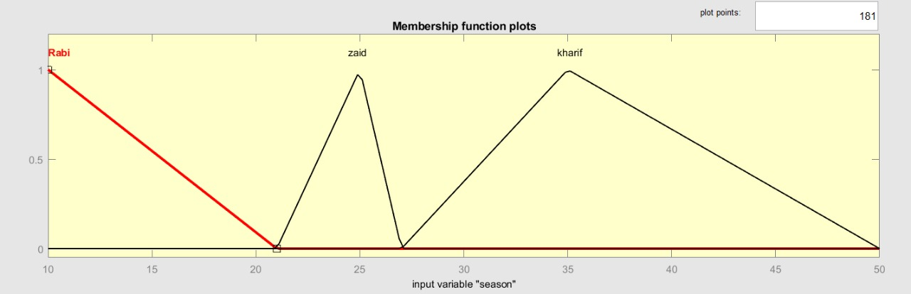

**Fig 5: Membership function of season is defined as Rabi[0,21], Zaid[21,27], Kharif[27,50]**

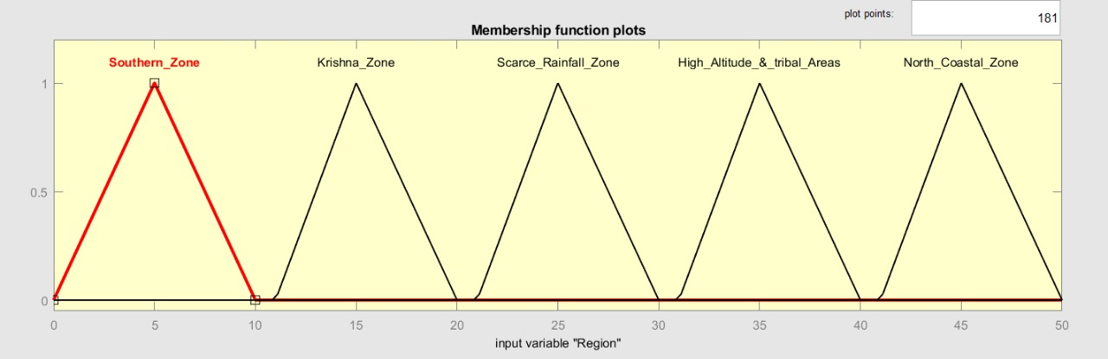

**Fig 6: Membership function of Region is defined as Southern_Zone[0,10], Krishna_Zone[11,20], Scarce_Rainfall_Zone[21,30], High_Altitude & Tribal_Zone[31,40], North_Coastal_zone[41,50]**

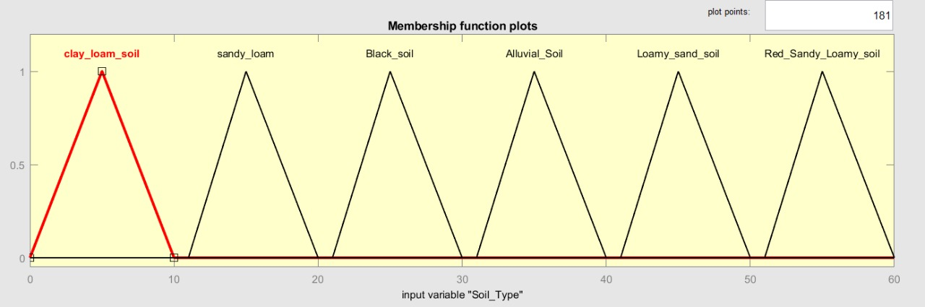

**Fig 7: membership function of Soil_Type is defined as Clay_loam_soil[0,10], Sandy_loam[11,20], Black_soil[21,30], Alluvial_soil[31,40] , Loamy_sand_soil[41,50],Red_sandy_loamy_soil[51,60]**

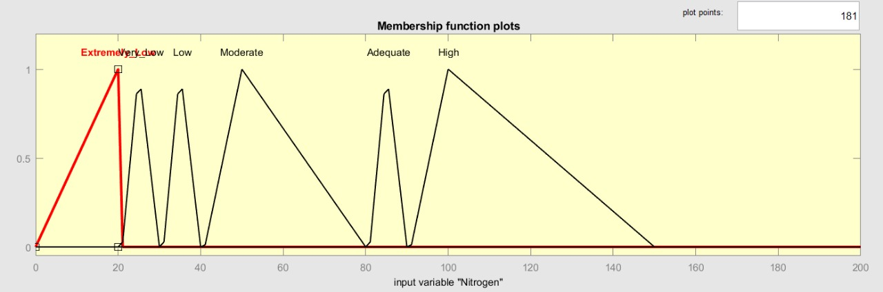

**Fig 8:Membership function of Nitrogen is defined as Extremely_low[0,20], Very_low[21,30], Low[31,40], Moderate[41,80], Adequate[81,90], High[91,150]**

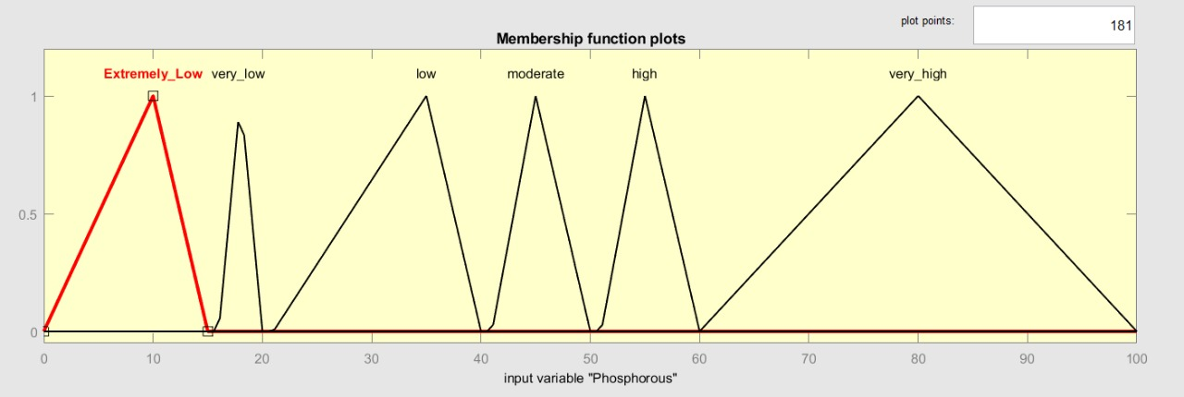

**Fig 9: Membership function of Phosphorous is defined as Extremely_low[0,15],Very_low[16,20],Low[21,40],Moderate[41,50],High[51,60],Very_High[61,100]**

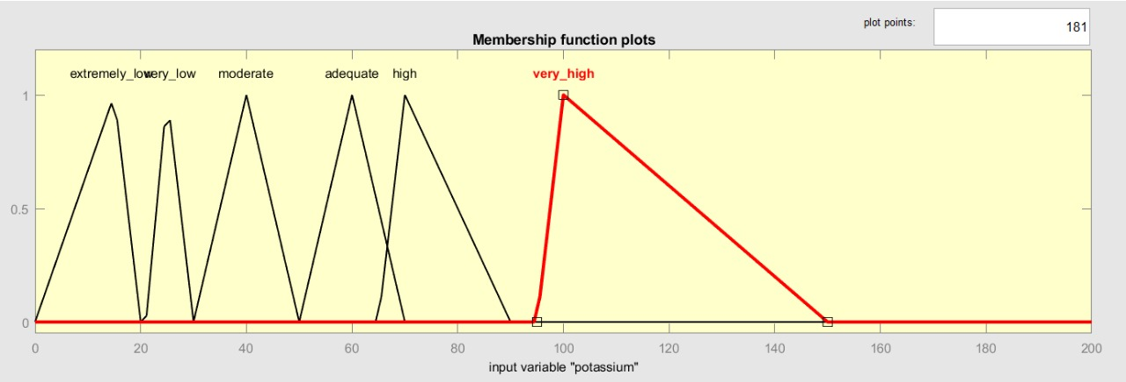

**Fig 10: Membership function of potassium is defined as Extremely_low[0,20], low[21,30], Moderate[30,50], Adequate[50,70], High[65,90], Very_High[95,150]**

1. **Choosing the output factors:**

Despite the fact that there is no shortage of crops that can be produced exactly in Andhra Pradesh's environment, just a few key crops have been included in our model rule-based expert system for analysis and testing reasons. Paddy, Wheat, Sugarcane, Maize, Millets, Pulses, Chilies, Cotton, Groundnut, and Tobacco are among the 10 crops chosen from a large number of options.

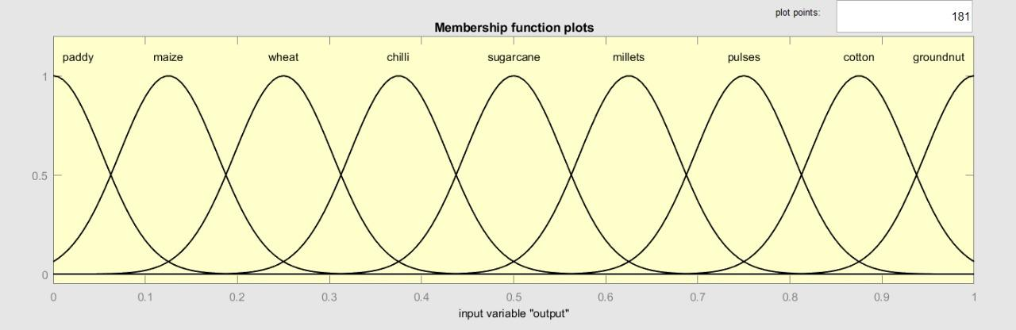

**Fig 5: Membership function for output variable “crop class”**

1. **Formulating Rules:**

Many distinct input limitations exist for only a few crops. The 'or' operator in a rule is not supported by the MATLAB Fuzzy Toolbox. As a result, it should be written independently. As a result, the number of rules exceeds the number of crops since certain crops have more than one rule in the case of some 'or' condition. In addition, certain rules have been modified to incorporate the output crops in the view and provide a better comprehension of the rules. The following are the rules for a few specific crops:

**Table 1: Rules defined for the crop selection based on 10 different input features**

|  |  |  |
| --- | --- | --- |
| **S.no** | **Rules** | **Class** |
| 1 | If (N,P,K ratio is 150 : 50 : 80) &&(rainfall is greater than 100cm or 100cm) && (humidity is between 60%-80%) && (temperature is between 21°C-37°C) && (soil is Clay loam Soil) && (region is Scarce rainfall zone) && (soil PH is 6) && (season is Kharif) | Paddy |
| 2 | If (NPK ratio is 80 : 40 : 40) && (rainfall is between 31cm-38cm) && (humidity is between 40%-60%) && (temperature is between 20°C-35°C) && (soil is Clay loam Soil or sandy loam or black soil) && (region is High Altitude and tribal areas) && (soil PH is 6-7) && (season is Rabi) | Wheat |
| 3 | If (NPK ratio is 150 : 80 : 80) &&(rainfall is between 110cm-150cm) && (humidity is between 40%-80%) && (temperature is between 15°C-45°C) && (soil is Alluvial Soil or Black Soil) && (region is North coastal zones) && (soil PH is 6.5-7.5) && (season is Kharif) | Sugarcane |
| 4 | If (NPK ratio is 150 : 80 : 80) &&(rainfall is 50cm-100cm) && (humidity is 35%-65%) && (temperature is 21°C-27°C) && (soil is Loamy sand Soil or Clay loam soil) && (region is High Altitude and tribal areas) && (soil PH is 5.5-7.3) && (season is Kharif orRabi or Zaid) | Maize |
| 5 | If (NPK ratio is 30 : 15 : 15) && ( rainfall is between 35cm-40cm) && (humidity is between 11-25%) && (temperature is between 25°C-29°C) && (soil is Clay loam Soil or Sandy loam or Loamy soil ) && (region is Krishna zone) && (soil PH is 5.5-7) && (season is Kharif or Rabi) | Millets |
| 6 | If (NPK ratio is 30 : 60 : 30) && ( rainfall is 60cm-90cm) && (humidity is 70%)&& (temperature is 20°C-37°C)&& (soil is Clay loam Soil , Sandy loam , Loamy soil ) && (region is Krishna zone) && (soil PH is 5.5-7) && (season is Kharif orRabi) | Chili |
| 7 | If (NPK ratio is 20 : 40 : 20) && ( rainfall is between 40cm-50cm) && (humidity is between 13%-16%) && (temperature is between 20°C-25°C) && (soil is Loamy soil ) && (region is High Altitude and tribal areas) && (soil PH is >5.2) && (season is Kharif or Rabi or Zaid) | Pulses |
| 8 | If (NPK ratio is 80 : 40 : 40) && ( rainfall is between 55cm-95cm) && (humidity is between 6%-8%) && (temperature is between 15°C-30°C) && (soil is Alluvial Soil or Clayey or Red sandy Loam soil) && (region is Krishna zone) && (soil PH is 6-6.5) && (season is Kharif) | Cotton |
| 9 | If (NPK ratio is 40 : 40 : 60) && ( rainfall is between 45cm-120cm) && (humidity is 9%) && (temperature is between 27°C-30°C) && (soil is Sandy loamy soil or Clayey Loamy Soil) && (region is Southern zone) && (soil PH is between 5.5-6.5) && (season is Kharif or Rabi or Zaid) | Groundnut |
| 10 | If (NPK ratio is 90 : 22 : 120) && ( rainfall is between 50cm-100cm) && (humidity is between 70%-75%) && (temperature is 23.5°C-30°C) && (soil is Light and Sandy soil) && (region is Scarce rainfall zone) && (soil PH is 5.8-6) && (season is Rabi) | Tobacco |

**IV.CONCLUSION**

This suggested method is an attempt to create a system that can recommend different crops for a given piece of land that is both efficient and accurate. For the Indian state of Andhra Pradesh, fuzzy logic was used to consider minimum criteria such as soil nutrients, soil PH, temperature, rainfall, land location, and season. The suggested system's performance was evaluated for 10 of Andhra Pradesh's most popular crops. Farmers in Andhra Pradesh would be able to make more informed selections while picking crops in order to maximize income.

**REFERENCES**

1. Prabakaran, G., Vaithiyanathan, D., & Ganesan, M. (2021). FPGA based effective agriculture productivity prediction system using fuzzy support vector machine. *Mathematics and Computers in Simulation*, *185*, 1-16.
2. Ingole, K., Katole, K., Shinde, A., & Domke, M. (2013). Crop prediction and detection using fuzzy logic in MATLAB. *International Journal of Advances in Engineering & Technology*, *6*(5), 2006.
3. Garg, B., Aggarwal, S., &Sokhal, J. (2018). Crop yield forecasting using fuzzy logic and regression model. *Computers & Electrical Engineering*, *67*, 383-403.
4. Arogundade, O. T., Atasie, C., Misra, S., Sakpere, A. B., Abayomi-Alli, O. O., &Adesemowo, K. A. (2020, December). Improved predictive system for soil test fertility performance using fuzzy rule approach. In *International Conference on Soft Computing and its Engineering Applications* (pp. 249-263). Springer, Singapore.
5. Murmu, S., & Biswas, S. (2015). Application of fuzzy logic and neural network in crop classification: a review. *Aquatic Procedia*, *4*, 1203-1210.
6. Kale, S. S., & Patil, P. S. (2019). Data mining technology with fuzzy logic, neural networks and machine learning for agriculture. In *Data management, analytics and innovation* (pp. 79-87). Springer, Singapore.
7. Jawad, F., Choudhury, T. U. R., Sazed, S. A., Yasmin, S., Rishva, K. I., Tamanna, F., & Rahman, R. M. (2016, June). Analysis of optimum crop cultivation using fuzzy system. In *2016 IEEE/ACIS 15th International Conference on Computer and Information Science (ICIS)* (pp. 1-6). IEEE.
8. Tilva, V., Patel, J., & Bhatt, C. (2013, November). Weather based plant diseases forecasting using fuzzy logic. In *2013 Nirma University International Conference on Engineering (NUiCONE)* (pp. 1-5). IEEE.
9. Noguchi, N., Reid, J. F., Zhang, Q., & Tian, L. F. (1998). Vision intelligence for precision farming using fuzzy logic optimized genetic algorithm and artificial neural network. *ASAE paper*, *983034*.
10. Garg, B., Aggarwal, S., &Sokhal, J. (2018). Crop yield forecasting using fuzzy logic and regression model. *Computers & Electrical Engineering*, *67*, 383-403.
11. Bang, S., Bishnoi, R., Chauhan, A. S., Dixit, A. K., & Chawla, I. (2019, August). Fuzzy logic based crop yield prediction using temperature and rainfall parameters predicted through ARMA, SARIMA, and ARMAX models. In *2019 Twelfth International Conference on Contemporary Computing (IC3)* (pp. 1-6). IEEE.
12. Kozlovskyi, S., Mazur, H., Vdovenko, N., Shepel, T., &Kozlovskyi, V. (2018). Modeling and forecasting the level of state stimulation of agricultural production in Ukraine based on the theory of fuzzy logic.
13. Kuzman, B., Petković, B., Denić, N., Petković, D., Ćirković, B., Stojanović, J., &Milić, M. (2021). Estimation of optimal fertilizers for optimal crop yield by adaptive neuro fuzzy logic. *Rhizosphere*, *18*, 100358.
14. Shastry, A., Sanjay, H. A., & Hegde, M. (2015, June). A parameter based ANFIS model for crop yield prediction. In *2015 IEEE International Advance Computing Conference (IACC)* (pp. 253-257). IEEE.
15. Ingole, K., Katole, K., Shinde, A., & Domke, M. (2013). Crop prediction and detection using fuzzy logic in MATLAB. *International Journal of Advances in Engineering & Technology*, *6*(5), 2006.
16. Ingole, K., Katole, K., Shinde, A., & Domke, M. (2013). Crop prediction and detection using fuzzy logic in MATLAB. *International Journal of Advances in Engineering & Technology*, *6*(5), 2006.
17. Jayaram, M. A., & Marad, N. (2012). Fuzzy inference systems for crop yield prediction. *Journal of Intelligent Systems*, *21*(4), 363-372.
18. Garg, B., Sah, T., & Aggarwal, S. (2018). Wheat yield forecasting using fuzzy logic. *International Journal of Convergence Computing*, *3*(1), 35-47.